Q1



An = 2An-1 – An-2, A1 = 3,A0 = 0

a)



An – An-1 = 2An-1 – An-2



= An-1-An-2



= A1-A0



=3-0 =3

An = An-1 +3

=An-2+ 3+3

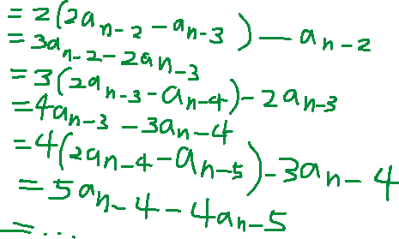

=…

=An-(n-1) +3(n-1)

=A1 +(n-1)x3

=3+3(n-1)

=3n

b) An = 2An-1 – An-2, A1 = 3,A0 = 0



x^2 = 2x-1

x^2 -2x+1 = 0

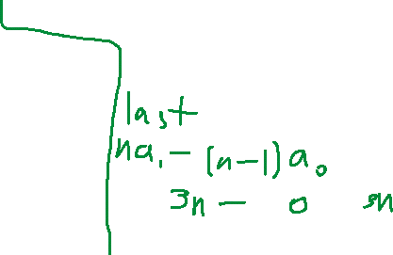

(x-1)^2 = 0

X=1



An = u\*S^n +V\*n\*S^n

u\*1^1+V\*1\*1^1 =3

u+v=3

u\*1^0+V\*0\*1^0 = 0

u = 0

v=3

An = u+v n

=3n



Q2

An = 2An-1+ An-2 -2An-3, A0=1, A1=2 , A2=0

X^3 = 2x^2 +x -2

X^3 -2x^2-x+2 = 0

X= -1, x=2, 1

An = u\*S1^n+v\*S2^n + w\*S3^n

0= u(-1)^2 +v \*2^2+w\*1^2

0 = u +4v+w --------------(1)

2= u\*(-1)^1+ v\*2^1+w\*1^1

2=-u+2v+w----------------(2)

1= u\*(-1)^0 +v\*2^0+w\*1^0

1=u+v+w--------------------(3)

(3) in (1): 0 = u+4v+1-u-v

0=3v+1

V= -1/3

(3) in(2): 2 = -u+2(-1/3)+1-u+1/3

2=-u-2/3 +1 -u +1/3

2/3-2u=2

2/3-2=2u

U=-2/3

W=1—2/3—1/3 = 2



An = -2/3 \* (-1)^n + -1/3(2^n)+2

Q3



An=C1An-1+C2An-2+,,,+CkAn-k

A’n=C1A’n-1+C2A’n-2+…+CkA’n-k

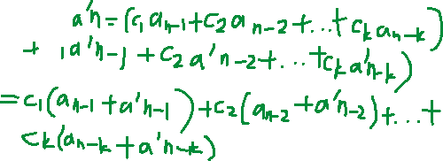

An+1+A’n+1-An-A’n = C1An +C2 An

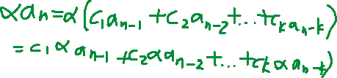

=α An

Thus An+A’n and α An also satisfy the linear homogeneous recurrence



Q4

An = 4An-1-3An-2 , A1=0, A2 = 12

X^2 = 4x-3

X^2-4x+3 = 0

(x-1)(x-3) = 0

X=1,x=3

An = u\*S1^n+v\*S2^n

0=u\*1^1+v\*3^1

0=u+3v----------(1)

12 = u\*1^2+v\*3^2

12=u+9v-------------(2)

6v=12

V=2

U=-6

An = -6+2(3^n)



Q5

An = 3An-1 -1, A1 =1

An-1 = 3An-2 -1

An-An-1 = 3An-1 -1 -3An-2 +1

= 3An-1 – 3An-2

An = 4An-1 -3An-2

From qn 4,X=1,x=3

1=3A0 -1

3A0=2

A0 = 2/3

1=u\*1^1+v\*3^1

1=u+3v

2/3 = u\*1^0+v\*3^0

2/3 = u+v

2v = 1/3

V=1/6

U=1/2



An = ½ + 1/6(3^n)

Q6

An = 4An-1-4An-2, A0 = 1,A1 = 3

X^2 = 4x-4

X^2-4x+4 = 0

X=2

An = u \* S^n + v\* n \* S^n

1=u \*2^0+v \*2^0 \*0

1=u

3=u\*2^1+v\*2^1\*1

3=2v+2u

3=2+2v

V=0.5

An = 2^n+n/2(2^n)



=2^n(1+ n/2)